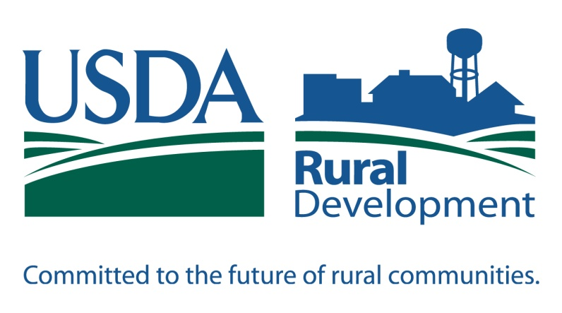  … we’re here to help YOU! | - At USDA Rural Development we invest in people, families, businesses, and communities. We are committed to supporting rural communities and know that many more individuals and families are still in need of service in Rural Missouri—especially those very-low, low, and moderate income households. Rural Development is looking to continue to serve these rural Missourians’ housing needs—in both homeownership and home repair—we’re here to help you!

502 Direct Program |  | Homeownership
BENEFITS TO THIS PROGRAM:
- No down payment — 100% financing
- Fixed rate of interest
- Offers payment assistance to those who qualify
- Taxes and insurance are escrowed with monthly payment
- No Private Mortgage Insurance (PMI)

TO QUALIFY FOR THIS PROGRAM:
- Must have stable and dependable income which is sufficient income to repay the loan
- Gross household income must be within agency income limits (see below)
- Must have an acceptable credit history
- Must use the home to be purchased as a primary residence
- Must be of legal age to incur a loan obligation (18+)
- Currently do not own adequate housing (mobile homes excluded)
- Unable to obtain credit through a conventional lender
- Be a U.S. citizen or have Permanent Resident Alien Status

502 PROGRAM INCOME GUIDELINES: (Effective 2/7/2013)

 | 1 person | 2 persons | 3 persons | 4 persons | 5 persons | 6 persons | 7 persons | 8 persons
Adair | $28,050 | $32,100 | $36,100 | $40,100 | $43,300 | $46,500 | $49,700 | $52,950
Boone Howard | $36,950 | $42,250 | $47,500 | $52,800 | $57,000 | $61,250 | $65,450 | $69,700
Chariton | $31,900 | $36,500 | $41,050 | $45,600 | $49,250 | $52,900 | $56,550 | $60,200
Knox Schuyler | $27,000 | $30,850 | $34,700 | $38,550 | $41,650 | $44,700 | $47,800 | $50,900
Macon | $28,650 | $32,700 | $36,800 | $40,900 | $44,150 | $47,450 | $50,700 | $54,000
Randolph | $28,000 | $32,000 | $36,000 | $40,000 | $43,200 | $46,400 | $49,600 | $52,800
Scotland | $29,500 | $33,700 | $37,950 | $24,150 | $45,500 | $48,900 | $52,250 | $55,650
These are “adjusted” gross incomes. We can deduct $480 for each minor dependent, cost of childcare (for children under age of 12), and/or $400 if the applicant is handicapped or 62 years of age or older.

- Call Catherine or Janet today to discuss your options and see how Rural Development can help YOU! | www.rurdev.usda.gov |  | USDA Rural Development  2995 County Rd 1325  Moberly, MO 65270  (660) 263-7400, ext. 4  catherine.linneman@mo.usda.gov  janet.bottoms@mo.usda.gov
To file a complaint of discrimination, write to: USDA, Assistant Secretary for Civil Rights, Office of the Assistant Secretary for Civil Rights, 1400 Independence Avenue, S.W., Stop 9410, Washington, DC 20250-9410 Or call toll-free at (866) 632-9992 (English) or (800) 877-8339 (TDD) or (866) 377-8642 (English Federal-relay) or (800) 845-6136 (Spanish Federal-relay). “USDA is an equal opportunity provider and employer.”
Guaranteed Rural Housing Program | Homeownership
An option for those applicants whose income exceeds the 502 Direct program guidelines. Applicants make an application with participating lenders. The lender originates loans, processes applications, and submits the loans to USDA Rural Development for a commitment to guarantee the loan to the lender. Contact your local USDA Rural Development office for a list of approved lenders.

BENEFITS TO THIS PROGRAM:
- Loans are made up to 102% of the dwelling appraised value
- No down payment
- No Private Mortgage Insurance (PMI)
- 30-year fixed rate mortgage

TO QUALIFY FOR THIS PROGRAM:
- Must have stable and dependable income which is sufficient income to repay the loan
- Gross household income must be within HUD income limits (see below)
- Must have an acceptable credit history
- Must use the home to be purchased as a primary residence
- Currently do not own adequate housing
- Be a U.S. citizen or have permanent resident alien status

GUARANTEED PROGRAM INCOME GUIDELINES: (Effective 2/7/2013)

These are “adjusted” gross incomes. We can deduct $480 for each minor dependent, cost of childcare (for children under age of 12), and/or $400 if the applicant is handicapped or 62 years of age or older.

 | 1 to 4 person household | 5 to 8 person household
Boone - Howard | 75,900 | 100,200
Adair – Chariton – Knox - Macon – Randolph - Schuyler Scotland | 74,750 | 98,650

504 Loan/Grant Program | Home Repair
With spring just around the corner many people start to think about completing home repairs, but sometimes financial help is needed. That’s where USDA Rural Development may be able to help. Rural Development offers two programs to assist homeowners with repairs to their dwellings—loans and grants. Most common types of repairs include new furnace installation, roof replacement, siding replacement, sanitary water and waste systems (septic/lagoon), update wiring, window replacement, wheelchair ramps and accessibility items to persons with disabilities.

TO QUALIFY FOR THIS PROGRAM:
- Be A U.S. Citizen or have Permanent Resident Alien Status
- Possess legal capacity
- Be the owner and occupant of the home
- Gross Household Income Must Be Within Agency Income Limits (See Below)
LOANS | GRANTS
- All loans at 1% and cannot exceed a 20 year term (Example: $20,000 loan at 1% for 20 years would be $92/month)  - Outstanding loans cannot exceed $20,000 | - Applicants must be 62 years of age or older and unable to repay a loan  - Lifetime grant assistance cannot exceed $7,500  - 3-year grant agreement entered into with the agency
504 PROGRAM INCOME GUIDELINES: (Effective 2/7/2013)
 | 1 person | 2 persons | 3 persons | 4 persons | 5 persons | 6 persons | 7 persons | 8 persons
Adair | $17,550 | $20,050 | $22,550 | $25,050 | $27,100 | $29,100 | $31,100 | $33,100
Boone - Howard | $23,100 | $26,400 | $29,700 | $33,000 | $35,650 | $38,300 | $40,950 | $43,600
Chariton | $19,950 | $22,800 | $25,650 | $28,500 | $30,800 | $33,100 | $35,350 | $37,650
Knox - Schuyler | $16,900 | $19,300 | $21,700 | $24,100 | $26,050 | $28,000 | $29,900 | $31,850
Macon | $17,900 | $20,450 | $23,000 | $25,550 | $27,600 | $29,650 | $31,700 | $33,750
Randolph | $17,500 | $20,000 | $22,500 | $25,000 | $27,000 | $29,000 | $31,000 | $33,000
Scotland | $18,450 | $21,100 | $23,750 | $26,350 | $28,500 | $30,600 | $32,700 | $34,800
These are “adjusted” gross incomes. We can deduct $480 for each minor dependent, cost of childcare (for children under age of 12), and/or $400 if the applicant is handicapped or 62 years of age or older.

