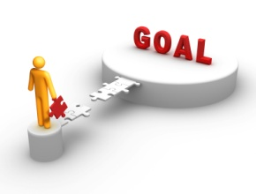 **4.**

**Creating a Path to Accessible and Affordable Inclusive Housing**

**Path to Success**

**7. First Steps**

***6. Charting Actions for the next few months***

**5. Ways to build Strength?**

**4. People to Enroll**

**3. Where am I (are we) now**?

**2. Where do you want to see yourself in one year?**

**1. What are Your Priorities?**

***Year***

-