MO Housing Solutions
Summer 2013

Our goal is to support individuals with developmental disabilities in obtaining safe, quality, accessible, affordable housing.

It has been a busy summer at Missouri Inclusive Housing Development Corporation. We have attended conferences and have traveled the state to talk about the need for safe, affordable, accessible housing for individuals with developmental disabilities. We have an ever increasing pool of developers interested in providing accessible housing around the state. This provides more options for the consumers and the providers supporting them.

Success Story

One of our successes with a developer has been the property below. Three women have moved from a habilitation center into their own home thanks to a developer who custom built this home for their specific needs. The developer and support staff sat down with the consumers and their families who provided input to construct this energy efficient, age-in-place home.

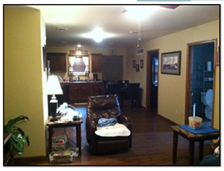
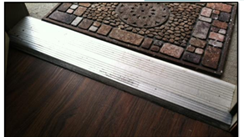
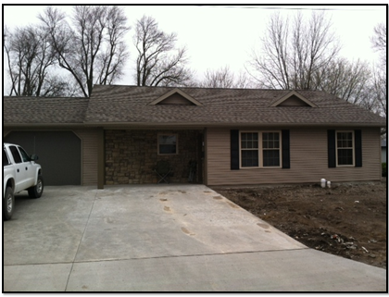

Exterior Flush Threshold-Hardwood floors Living Room
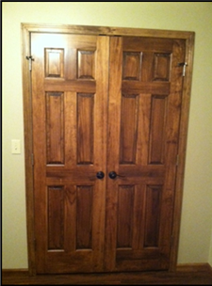
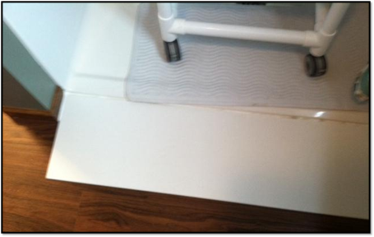
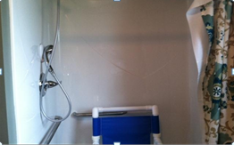

Zero entry shower Spacious Shower Magnetic Door Handles

Missouri Autism Report - August 2013

Check out this article on Missouri Inclusive Housing Development Corporation’s role in statewide efforts to put together the pieces of the housing puzzle. The article begins on page 6.

Solving the Housing Crisis: State and Private Organizations Join Forces to Find Answers

http://www.calameo.com/read/00093155104c546afd237

