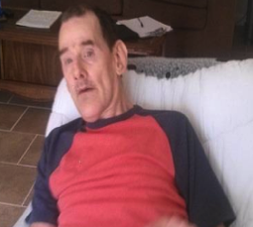

After living in an institutional setting for most of his life, 60 year old Hugh has a new rental home that meets his needs. Hugh’s dream was realized because the housing team, including his provider, the home builder/landlord, the Community Living Coordinator at Poplar Bluff Satellite Office, and MoHousing, worked together to make it happen. The builder worked to make this a home that incorporated universal design concepts so Hugh and his two roommates could “age in place”. Now that’s a success story!

**Team Work Makes it Happen!**