Companion is In-tune with LaJuan

Lajuan and kathy create a home with freedom and opportunity
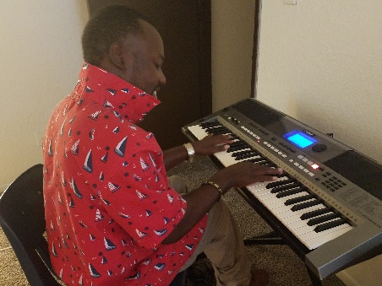
LaJuan believed his only residential option was to live with large numbers of people in a congregate setting. When he and his mother learned of the Companion Model option, they were thrilled to take advantage of it. They chose to connect with Resources for Human Development (RHD) in the Kansas City area.

“Living in a small family atmosphere provides me with freedom and peace I didn’t have before living with a big group of people,” states LaJuan.
LaJuan creating his amazing beats and music on his keyboard

What is a Companion Model?
The companions assist with daily activities, such as; giving medication, assistance with hygiene and meal prep, and are part of social and recreational activities. There is a close relationship that comes from working together to achieve a peaceful and thriving home life. The companion model is truly that of a shared home. The person and companion bond closely and the home is truly that of the person.

Kathy is a pleasant, understanding lady that lives in the Companion Model with Lajuan. It made sense for her to share a home with this young man with Cerebral Palsy. “It’s great to have him and provides opportunities for both of us. I let him grow on his own. We’re like sister and brother!” Kathy cooks and LaJuan loves her meals. He is always happy to eat the food she prepares and is learning ways to assist in his home.

“I communicate to her and she’s always there to help me. I also love being spoiled with all my one-on-one time! We got a groove goin’!”

Kathy has gone the extra mile to connect LaJuan to those in her church who can help him meet his goal of recording his original music. We look forward to hearing your CD, LaJuan!

To learn more about Shared Living services and other residential services offered through the Department of Mental Health- Division of Development Disabilities go here:

https://dmh.mo.gov/dev-disabilities/programs/waiver/medicaid-hcb

To share in the success of other individuals and families, visit: https://dmh.mo.gov/opla/sharing-success-stories

