**Success Stories**

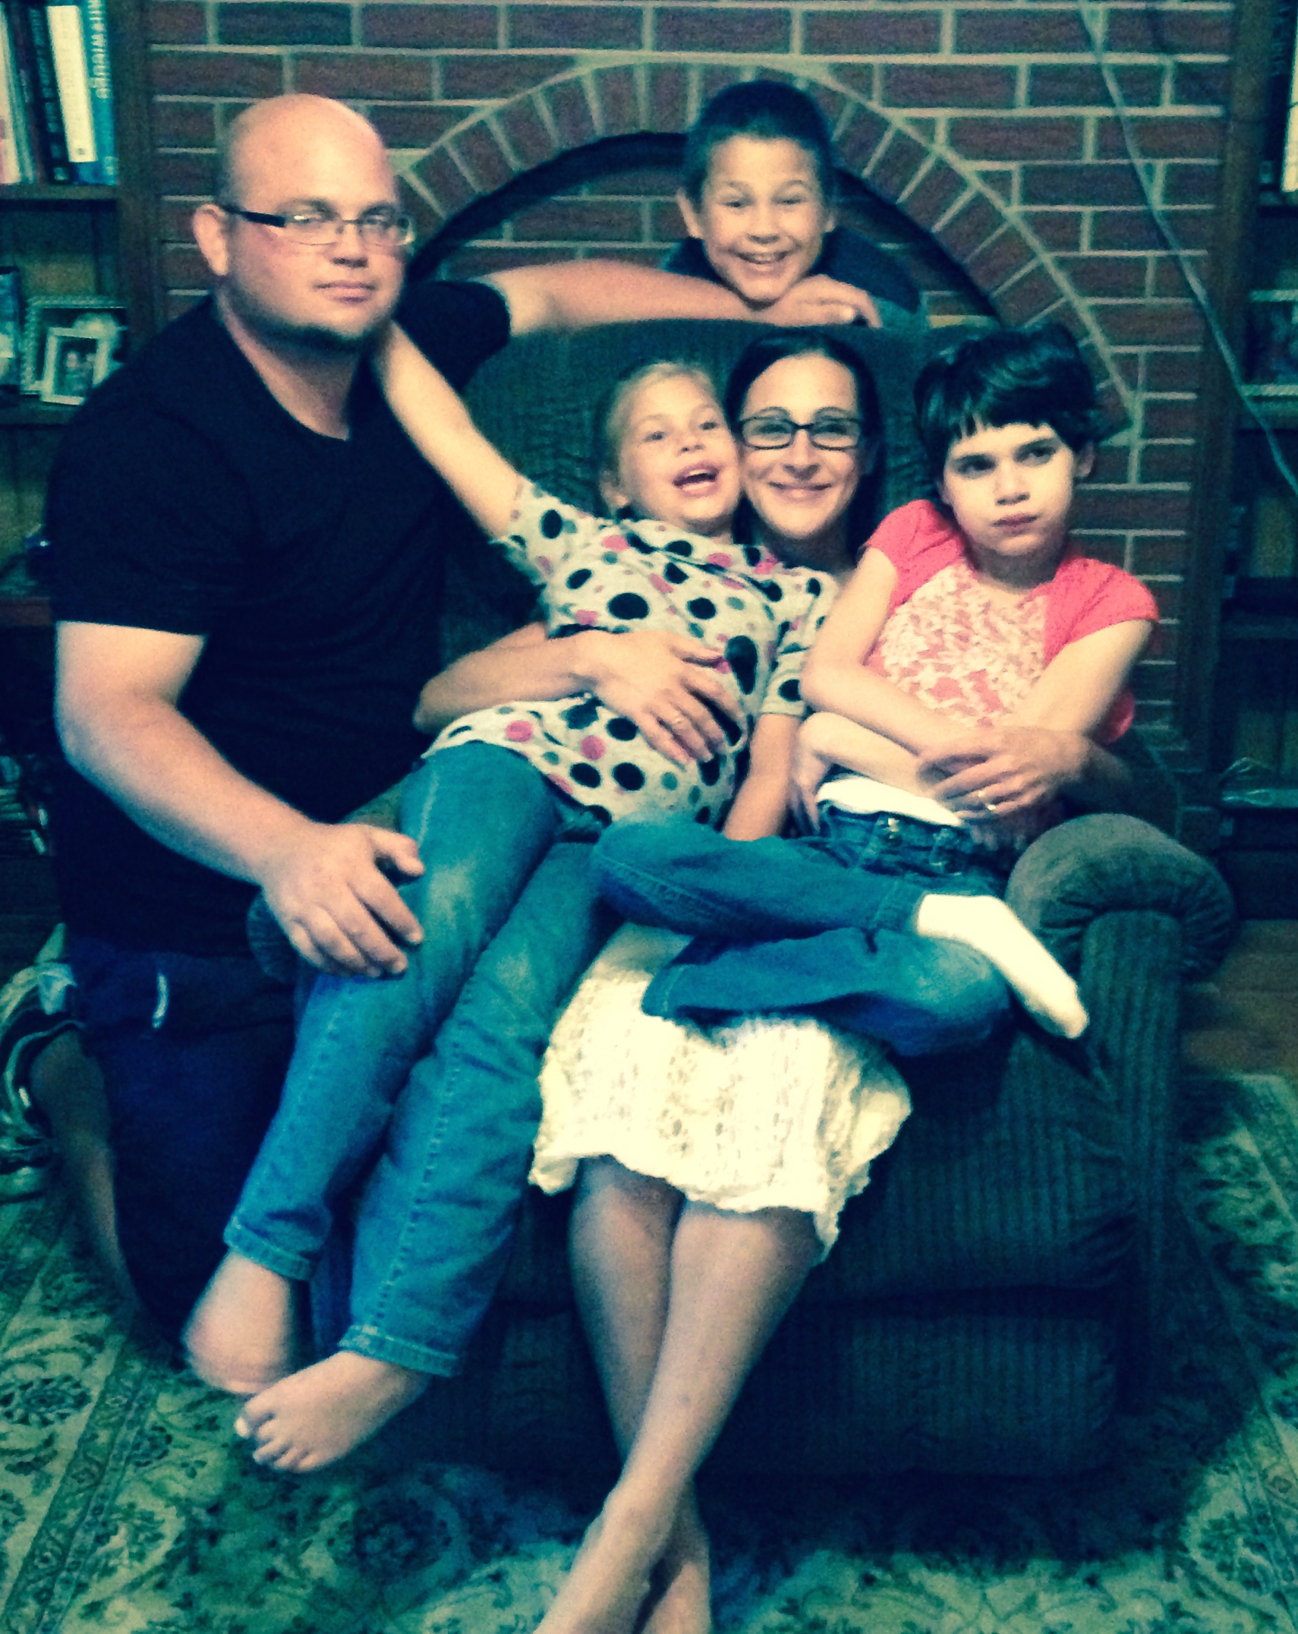`

**The Walker Family**

Finding housing for a family of five is always difficult. Finding housing that accommodates mobility issues while living in the area of their choice seemed like an impossible dream to the Walkers. The family’s three-story rental home was definitely not meeting their needs. Purchasing a home was put on the table as a possibility. Building a new custom home in the area was cost prohibitive. The search began for a home that could be retro-fitted to accommodate their daughter’s wheelchair. After a long search, a ranch-style home was found that fit the bill. Financing was secured through a VA loan. MoHousing, along with the Community Living Coordinator in their region, assisted them in finding their dream home where they could live comfortably together as a family.